|  |  |  |  |
| --- | --- | --- | --- |
| Feature | Measurement Range | Description | Uncertainty Error |
| Humidity | 0-100% Relative Humidity | Humidity refers to the amount of water vapor in the air. | ±3% |
| Pressure | 300 – 1100 hPa | Pressure refers to the force exerted on a surface by atmospheric air. | ±1.0 hPa |
| Temperature | -40°C – 85°C | Temperature is the average kinetic energy of molecules within a substance or system. | ±1.0°C |
| CH4 | >1000ppm | CH4 refers to methane, a potent greenhouse gas. | ±15-25% |
| C2H5OH | 10-500ppm | C2H5OH refers to ethyl alcohol, an organic compound which can become suspended in the air. | ±15-25% |
| H2 | 1-1000ppm | H2 refers to hydrogen, a low-density gas. | ±15-25% |
| NH3 | 1-500ppm | NH3, also known as ammonia, is a colorless gas that is emitted from agricultural practices. | ±15-25% |
| C4H10 | >1000ppm | C4H10, also known as iso-butane, is an organic compound commonly used as cooking gas. | ±15-25% |
| C3H8 | >1000ppm | C3H8 refers to propane, a gas that is commonly used as fuel. | ±15-25% |
| NO2 | 0.05-10ppm | NO2, known as nitrogen dioxide, is a highly reactive gas that contributes to ground-level ozone and acid rain. | ±15-25% |
| P1 Concentration | 0-8000 particles/0.01cf | P1 concentration refers to the physical concentration of particles over 1µm in diameter, which is calculated from the P1 Ratio. | Unknown |
| P1 LPO | µ-sec | P1 LPO, known as low pulse occupancy, represents the amount of time that the sensor reads a low pulse during a 15-second period for particles over 1µm, which is proportional to PM concentration. | Unknown |
| P1 Ratio | 0-100% | P1 ratio refers to the ratio between the P1 LPO time and the sample time, which was set to 15 seconds. | Unknown |
| P2 Concentration | 0-8000 particles/0.01cf | P2 concentration refers to the physical concentration of particles over 2.5µm in diameter, which is calculated from the P2 Ratio | Unknown |
| P2 LPO | µ-sec | P2 LPO, known as low pulse occupancy, represents the amount of time that the sensor reads a low pulse during a 15-second period for particles over 2.5µm, which is proportional to PM concentration. | Unknown |
| P2 Ratio | 0-100% | P2 ratio refers to the ratio between the P2 LPO time and the sample time, which was set to 15 seconds. | Unknown |

MICS6814, 101020088 multichannel gas sensor - <https://pdfs.semanticscholar.org/bad6/02844cde6885d200939d0764101de22fb0c3.pdf>

<https://sgx.cdistore.com/datasheets/sgx/1143_datasheet%20mics-6814%20rev%208.pdf>

BME280 - <https://cdn-learn.adafruit.com/assets/assets/000/115/588/original/bst-bme280-ds002.pdf?1664822559>

PPD42NS - <https://pdfs.semanticscholar.org/d604/cb40a58c7771e40b814b1c1834511f4b692f.pdf>

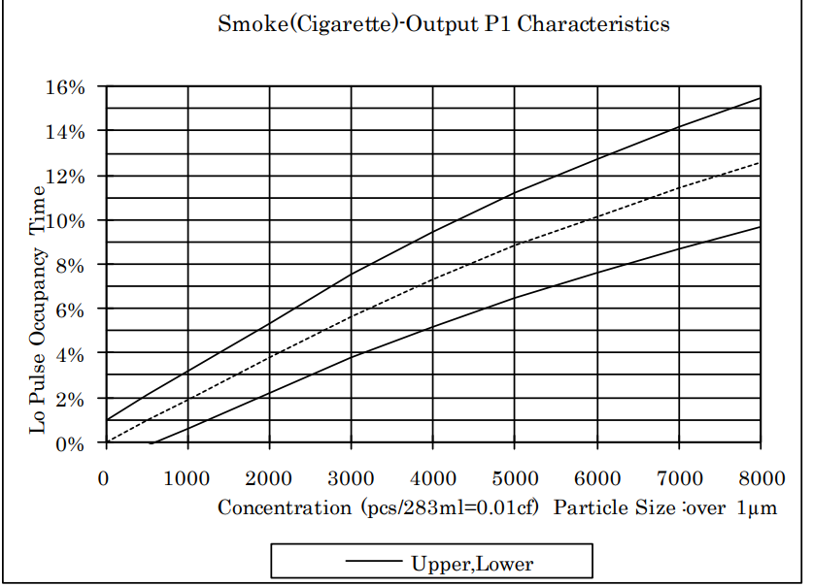

Datasheet and Graph for PPD42NS- https://files.seeedstudio.com/wiki/Grove_Dust_Sensor/resource/Grove_-_Dust_sensor.pdf